# Day 3 – #60DaysOfDevOps Challenge

Today's focus was mastering Git fundamentals, including branch operations, merging strategies, conflict resolution, and working with Git history. Here's a breakdown of the challenges completed:

## ✅ Challenge 1: Clone Your Fork

Use the terminal to clone your forked GitHub repository:  
git clone <https://github.com/Jeslinanista/eks-auto-mode-workshop.git>

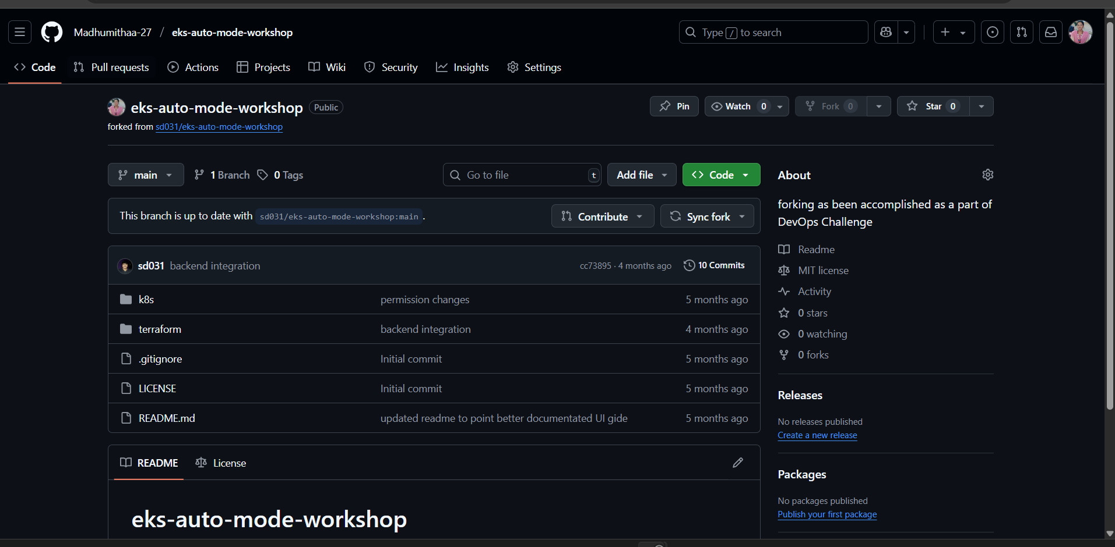

## ✅ Challenge 2: Create a Feature Branch

Create and switch to a new branch:  
git checkout -b feature-branch

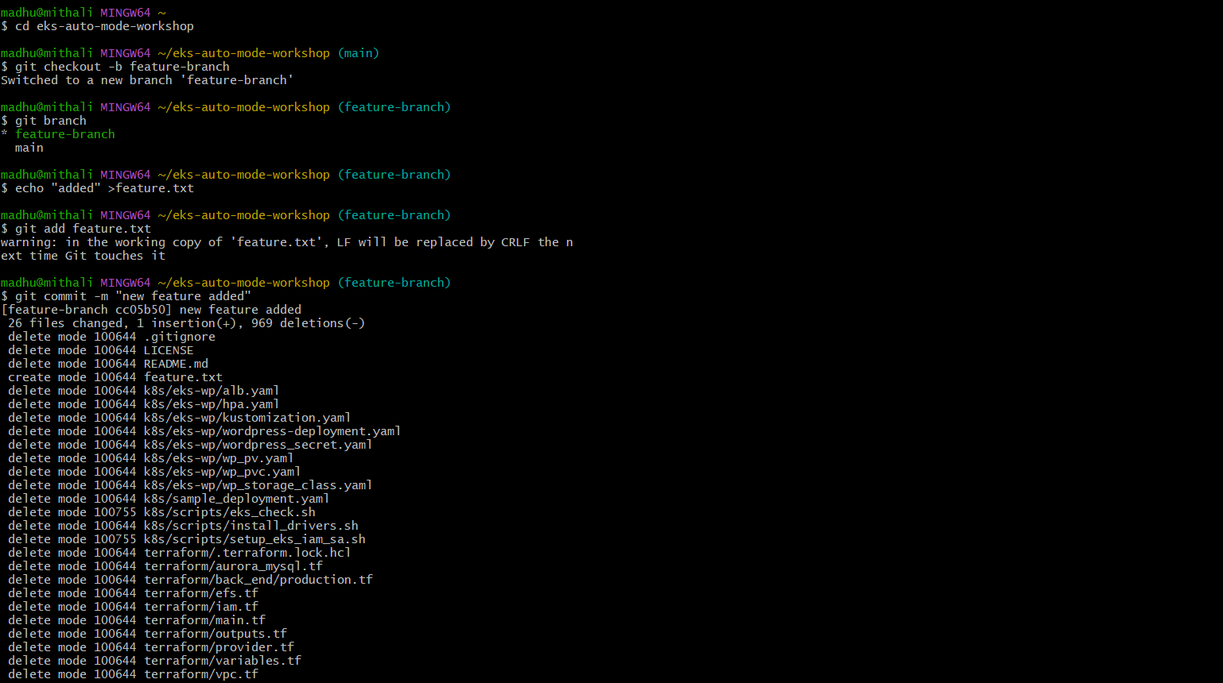

## ✅ Challenge 3: Make a Change

Add a new file with a greeting:  
echo   
git add   
git commit -m

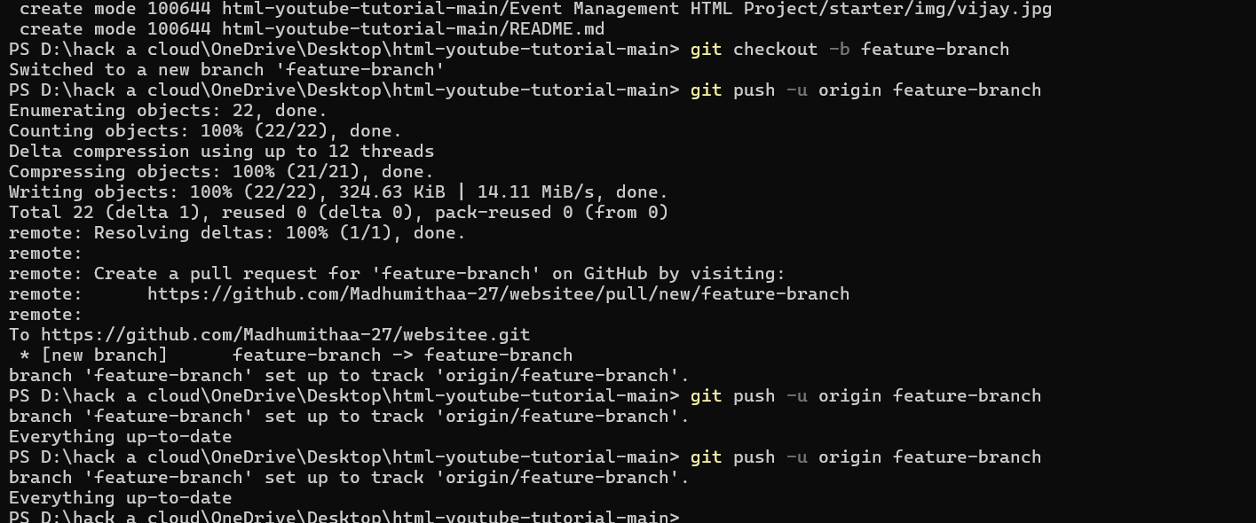

## ✅ Challenge 4: Use git reset or git revert to undo a commit.

## Answer :

## Using git reset:

## Completely Remove the Last Commit

## git reset --hard HEAD~1

## Explanation:

## --hard → Removes the commit and discards changes.

## If you want to undo the commit but keep the changes:

## git reset --soft HEAD~1

## Using git revert to Undo a Specific Commit Without Changing History

## git revert <commit-hash>

## Example:

## git log --oneline to find the commit hash and then revert to the old commit

## 🕘 View Commit History & Revert a Commit

## # Show concise commit history

## git log --oneline

## Example Output:

## d3f3c12 Added a new feature

## b2a1f98 Fixed a bug

## # Revert a specific commit by hash

## git revert d3f3c12

## Bonus 💡 If you've already pushed the commit to GitHub and need to force-push:

## git push origin main --force # Use with caution!

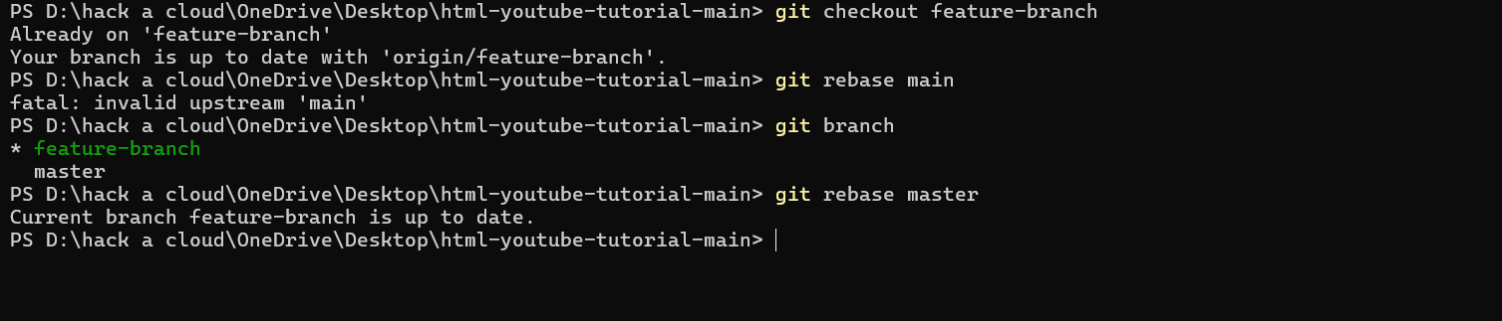

✅ **Challenge 5**: **Rebase**feature-branch**onto**main**and understand the difference.**

**Answer:**

**First what is exactly a Git Rebase:**

git rebase is a command that moves or combines commits from one branch onto another, rewriting commit history in a linear way.

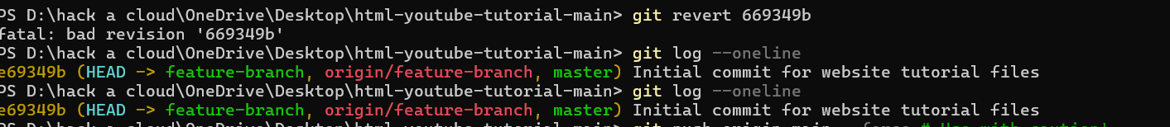

**Challenge 6**: **Create a PR on GitHub from a feature branch.**

**Answer:**

**We can create a Pull Request (PR) on GitHub from a**feature-branch**using the following steps:**

